Name: Abrha Gebreslassie, Berhe

Subject: Lab Assignment - 4

**Problem – 1-A: UML Diagram**

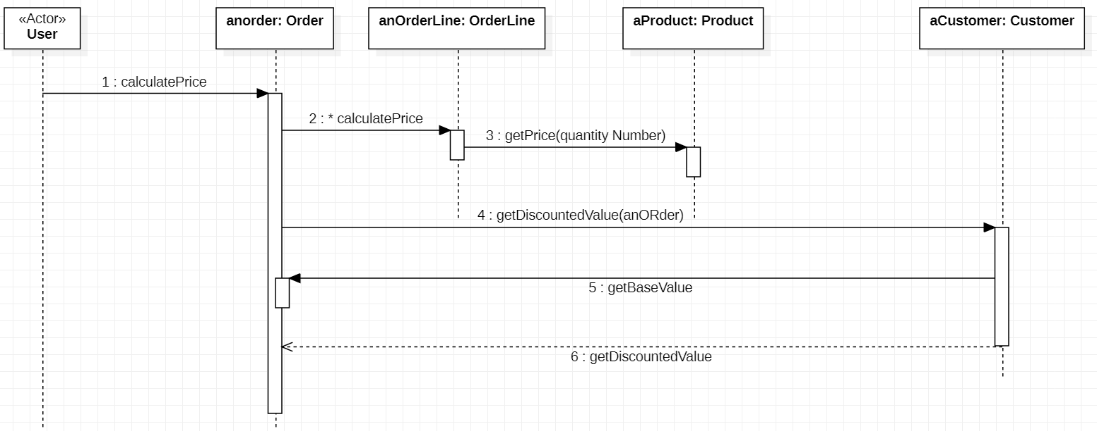

**Problem – 1-B: UML Diagram**

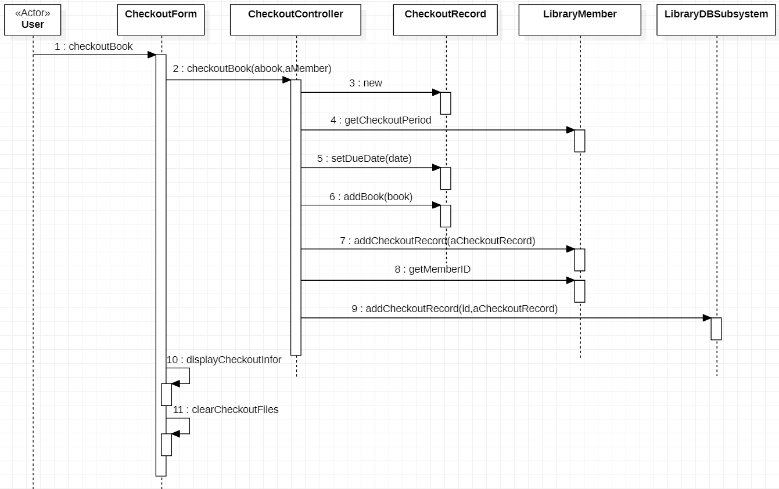

**Problem – 1-D**

